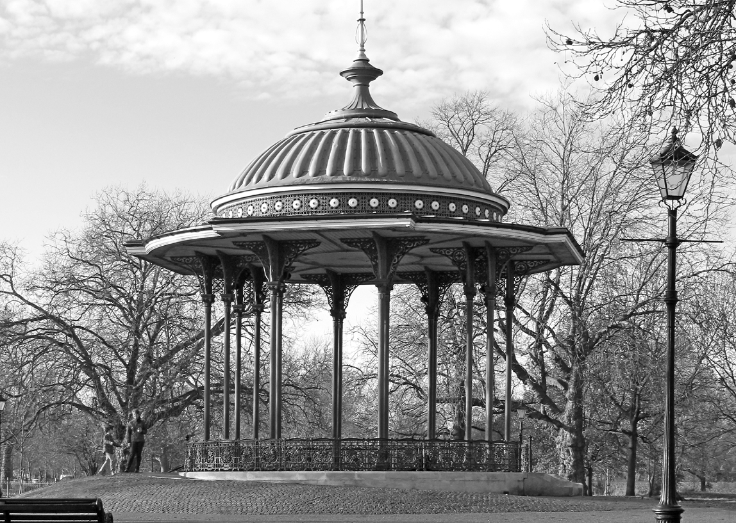Meetings are held at Clapham Picturehouse,
76 Venn Street, London SW4 OAT

Doors open at 10.30am Lectures commence at 11am

Committee
Chairman: Gena Gilbert
Vice Chairman: Susan Holder Programme Secretary: Caroline Christie Treasurer: Juliet Upton
Publicity: Nikki Brine
Honorary Secretary: Elizabeth Kennedy Membership Secretary: Virginia Stevens

Contact ClaphamCommon@TheArtsSociety.org www.TheArtsSociety.org/ClaphamCommon
The Arts Society Clapham Common cannot be held responsible for any personal accident, loss, damage or theft of members’ personal property. Members are covered against proven liability of Third Parties.

Lecture Programme 2017/2018

Member

15 March 2017
2017/2018
The Boy Who Bit Picasso

Antony Penrose

19 April 2017
Great Tarts in Art: High Culture and the Oldest Profession

Linda Smith

17 May 2017
Vivaldi in Venice

Peter Medhurst

21 June 2017
From Flea-Pit to Picture Palace:
A History of British Cinema Architecture

Andrew Davies

20 September 2017
Wonder Workers and the Art of Illusion
(The History of Art through Magic and Pictures)

Bertie Pearce
18 October 2017
The Inside Stories: the Real Stories behind the most intriguing cases of Nazi Looted Art Shauna Isaac
2017/2018

15 November 2017
When Britain Clicked:
Fab Photographs from the Swinging Sixties

Brian Stater

6 December 2017
The Christmas Story in Medieval Art

Sally Dormer

17 January 2018
East meets West:
Japonism in South London and Beyond

Marie-Therese Barrett

21 February 2018
Artists and Espionage: The Lawn Road Flats: Modernist Living in Mid-20th Century London Deborah Lambert

