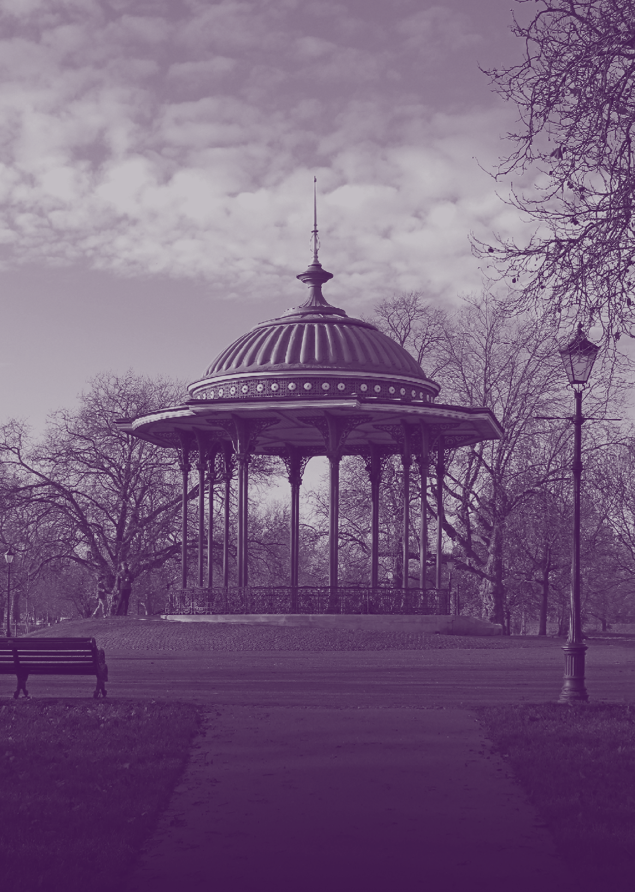

A new arts society that welcomes new members.
We have a varied programme of fascinating, illustrated lectures given by entertaining and knowledgeable professional speakers.
Lectures are held at the Clapham Picturehouse on the third Wednesday of the month at 11am.
For further details, please visit: TheArtsSociety.org/ClaphamCommon

